Format for formal Technical Reports

Write your report for a technically informed reader. You should write for your boss’s boss. Use good organization, be complete, check your spelling, question your grammar, and produce a neat, readable document.

A complete formal report contains these items and sections:

|  |  |
| --- | --- |
| 1. Cover Sheet or Title Page | 8. Procedures |
| 1. Abstract | 9. Results |
| 1. Table of Contents | 10. Discussion |
| 1. Introduction | 11. Conclusions or Summary |
| 1. Theory and Analysis Methods | 12. References |
| 1. Materials | 13. Appendices (as needed) |
| 1. Apparatus |  |

The following list of bullet items describes the appropriate information for each section. The list appears in the order that you must follow when writing your report.

I. Cover Sheet or Title Page

Present this information:

* Descriptive title of the laboratory experiment.
* Author name or names.
* Course and section number.
* Date that you performed the experiment.
* Date that you submitted report.
* Three to five key words placed near the bottom of the page.

II. Abstract

This is an *incredibly* short version of the report. Your boss’s boss might only have time to read the abstract; therefore, the abstract must present results.

* The abstract shall be a single paragraph.
* The abstract shall not exceed 200 words.

Include this information:

* + State the principal objective and scope of the investigation.
  + Describe the materials tested.
  + State the key experimental method(s) employed.
  + Summarize the results. If there are hard numbers, present some of them.
  + State principal conclusions, including how the results compared to other published data if applicable.

III. Table of Contents

Include the major sections of the report that follow the table of contents and the page number that each section begins on. The major sections are

* Do not enclose the page numbers in parentheses.
* Do not include the cover sheet or table of contents.

You may include subsections if you wish.

IV. Introduction

This section introduces the report itself. That is, it tells the reader how the report is organized and what to expect. A proper introduction must clearly present this information:

* Objective(s)
* Background

Please read the following subsections; they guide you toward writing an appropriate introduction.

* 1. Objective

You will improve your grade if you state the objective(s) in a single sentence that is easy to find. This sentence should be part of a complete paragraph that leads the reader into a discussion of the background. The reader must know exactly what the work was to accomplish, solve, prove, answer, etc.

* 1. Background

Establish general interest in the subject, that is, describe why the general topic is of interest to the reader. This section puts the subject in context for the reader and includes a relevant, referenced literature review.

V. Theory and Analysis Method(s)

Use this section to present the theoretical basis of the experiment and to show the analysis used to determine the outcome.

1. Theory
   * Present and discuss the theoretical basis for analyzing the experiment.
   * Hint: Present the equations in a sensible order. Simple equations precede more complex equations. Equations might follow the order of the analysis.
   * Present the equations used.
   * Format and number the equations properly.
   * Where did the equations come from? (Numbered references)
   * What does each parameter in every equation represent?
   * What are the SI units of each parameter?
   * Identify those parameters that come from your measurements and those that come from standard tables or other sources.
2. Analysis Method(s)
   * Describe in words how each type of data was processed.
   * If English units were used to collect the data and SI units used to process it—state that.
   * Tell the reader to look at an appendix for example calculations for EACH equation that you employed in your analysis.
   * Name each piece of software and hardware used in your analysis. If measurements were averaged on a calculator—state that. “Three measurements of the diameter were averaged on an HP-9000C calculator.” If the measurements were typed into Excel and averaged—state that. If data were processed in Excel and plotted in TechPlot—state that.
   * Explain your uncertainty analysis stating what the uncertainty of the dependent variable (?%).  Put details of the uncertainty analysis in the appendix.

VI. Materials

* Clearly describe each material studied.
* Classify each material (metal, ceramic, polymer, crystalline/amorphous, composite, etc.).
* State the chemical composition of each material. For polymers present a figure that shows the chemical structure of a single repeat unit (mer) of the chain.
* State the known initial thermal-mechanical processing of the material. For example, T6 condition, cold worked, etc.
* If the material was tested without a specific shape, e.g., hardness testing, describe the shape provided in this section.
* If the material has a functional shape for the experiment, state that the specimen design is discussed in the apparatus section that follows.

VII. Apparatus

1. Equipment

Introduce and describe every piece of equipment used to accomplish this work. (Who made the micrometer or caliper?)

* Explain anything unusual about the instruments or set-up.
* Describe instrumentation (measurement systems) used as related to the measurement locations on the diagram (with a statement of the uncertainty associated with each measurement system).
* Mention the manufacturer(s) of the machine(s) and model number(s).
* Present an illustrative diagram of the processing and test equipment. This diagram must show the general relationships among the various components of the system and the locations where measurements were taken.
* The illustrative diagram must be the work of the author(s) of the report. Use a drawing tools (pencils, pens, triangles, rulers), a drawing program (Corel Draw, drawing tools in WORD, or equivalent), or Solidworks (in 2D or 3D mode).

1. Specimens

If the specimen shape does not have a function then describe the specimen in the materials section above. However, if the shape of the specimen has a function you will discuss the specimen here.

* Give a clear description of the test specimens used. Include shape and dimensions
* Present an illustrative diagram of the specimen(s). This diagram must show the standard dimensions of the specimen.
* The illustrative diagram must be the work of the author(s) of the report. Use physical drawing tools (pencils, pens, triangles, rulers), a software drawing program (Corel Draw, drawing tools in WORD, or equivalent), or Solidworks (in 2D or 3D mode).

VIII. Procedures

* Do NOT write step-by-step instructions like those found in a manual.
* Discuss the general approach of each action taken.
* Hint: Discuss each procedure in the order of the equations presented in the analysis section. First, make sure that the equations appear in a reasonable order.
* If the procedure corresponds to an ASTM method note that in this section. If it is different state how it differs.

IX. Results

* You must “introduce” the results; that is, tell the reader what you are presenting. Mention the figure, table, or other exhibit by its name (‘Figure 3 shows…’) before that exhibit appears in the report.
* Explain all presented graphs and tables.
* Do not introduce a series of graphs in a single sentence. You must say something about each graph. (Can you put the graphs in an order that tells a story?)
* Present data in tables. Each column of data MUST have its **error** limits.

X. Discussion

1. Interpret and explain the results
2. Interpret the results for the reader; that is, tell the reader how to read or look at the results. Tell what your method of presentation illustrates or demonstrates and why the results were presented this way.
3. Explain any discrepancies, scatter of data, anomalies, etc. Explain why the results turned out as they did and if they were expected or unexpected and explain why. COMPARE YOUR RESULTS TO THOSE FOUND IN THE LITERATURE AND DISCUSS WHY THEY DO OR DO NOT AGREE.
4. Point out the important results
   1. Even if the results as presented seem obvious to you, you want to be sure your reader notices the most important features and trends, etc.
   2. State what you think the results show, prove, demonstrate, or illustrate.
   3. In this section you are “setting up” your conclusions. In fact, there may be conclusions stated in the discussion that you will restate in itemized form in the conclusions section.

XI. Conclusions, or Summary

* The title of this section is either “Conclusions” or “Summary.”
* State your conclusions; that is, itemize the most important things that you found out, measured, and observed. Anything that could be preceded by “It was found that” or “It was discovered that” is a finding, not a conclusion. This itemized list will give you a chance to think about what you discovered and aid you in identifying what you wish to conclude from the results of the experiment. Remember conclusions are generalizations based on results of a specific investigation.
* If you cannot state direct conclusions, present a summary and title this section “Summary.”

XII. Acknowledgements

This section is optional! No points are earned if you include acknowledgements and none will be taken away if you do not have them. However, you should know that—when acknowledgments are appropriate—they must appear between the conclusions and the references.

XIII. References

* Cite the references used.
* All citations must be noted in the body of your report. Use the correct format: author’s or editor’s names, title of paper or book, journal name or publishing house, vol. number, page numbers cited, date of publication.

XIV. Appendices

* You must place example calculations in an appendix! We cannot provide partial credit if we do not see your work. If you answers are correct, we cannot accept them if you do not show your work.
* If you present more than one appendix, ‘number’ them starting with A, e.g., Appendix A. Example Calculations, Appendix B. Analysis of Error, Appendix C. Derivation of Equations. Note that each appendix has a title phrase. If you have one appendix do not assign a letter, e.g., Appendix. Example Calculations.
* You may put special calculations, error analyses, etc. into appendices. The appendices should all be given a title and listed in the Table of Contents.

The details of the uncertainty analysis appear in an appendix.

XV. Layouts

Use the ‘traditional’ layout or an integrated layout for your report. Figure 1 shows both layouts. Traditional style puts the figures and tables at the end of the report. All tables appear, then all figures.

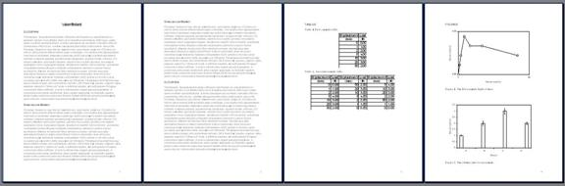

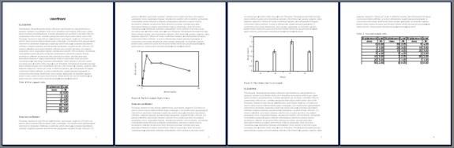

Figure 1. Reports can follow one of two layout schemes. Top) The traditional scheme presents the body of the text, then all tables in a “Tables” section, then all figures in a “Figures” section, and finally the appendices, which do not appear here. If an appendix has tables or figures these must follow the body of the appendix. Bottom) The integrated layout embeds the tables and figures between paragraphs. Each exhibit must appear *after* the paragraph where it is first mentioned in the text. Exhibits must appear in the order mentioned. For better pagination they may appear several paragraphs after they are mentioned if the order of exhibits follows their order of introduction in the text.

format requirements for GRAPHS

1. Number illustrations in sequence using Arabic numbers, and place the description and figure number UNDER the figure. Integrate the figures with the text—the figure appears at or after the end of the first paragraph that refers to it—or they may appear IN ORDER after all of the text.
2. Follow these guidelines:
   * The graph box must be in ratio of 5:3.
   * Smallest text or symbol must be 16 pt or larger.
   * Text within the chart box must be 16 pt or larger.
   * Numbers along the axes must be 18 pt.
   * Axes titles must be 20 point bold.
   * Titles must be "Noun (units)"; for example: Stress (MPa)
   * Figure title follows the format shown below. Use one or two sentences to describe the chart.
   * Where needed, use a legend to identify each data set plotted.
   * No grid lines within the chart.
   * Best practice is to use 2, 3, or 5 divisions on the axes.

Figure 2 demonstrates the format requirements. Use the WORD caption format for the title.

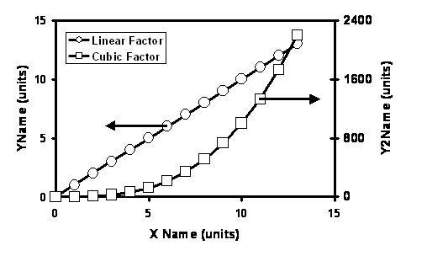

Figure 2. This graph conforms to the format requirements for the course. Two vertical axes make the two data sets visible on a single chart.

format requirements for Tables

1. Number tables in sequence using Arabic numbers, and place the caption and table number OVER the table. Integrate the tables with the text—the table appears after the first paragraph that refers to it—or they may appear IN SEQUENCE after all of the text.
2. Follow these guidelines:
   * The table must fit within the margins of the text.
   * Fonts must be 12 pt or larger.
   * Headings must be bold.
   * Use a logical place to show the units row and column units.
   * Use horizontal rules and white space to separate the values.
   * Use a consistent format the numbers and align the numbers for easy reading.
   * Use 3 significant figures with rounding OR 4 significant figures with truncation.
   * Use superscripts and subscripts—use 10-4—never use E4 notation.

Table 5 demonstrates these requirements for tables of numbers.

Table 5. Numbers in a table must illustrate the discussion in the text. Tables intended to record raw data must appear in an appendix. This table uses horizontal rules and white space to make the contents clear and easy to read.

